CCNA 3

**Enterprise Networking, Security, and Automation v7.0 (ENSA)**

1. Single-Area OSPFv2

1.1 OSPF Features and Characteristics

This topic is a brief overview of Open Shortest Path First (OSPF), which includes single-area and multiarea. OSPFv2 is used for IPv4 networks. OSPFv3 is used for IPv6 networks.

OSPF is a link-state routing protocol that was developed as an alternative for the distance vector Routing Information Protocol (RIP). RIP was an acceptable routing protocol in the early days of networking and the internet. However, the RIP reliance on hop count as the only metric for determining best route quickly became problematic. Using hop count does not scale well in larger networks with multiple paths of varying speeds. OSPF has significant advantages over RIP in that it offers faster convergence and scales to much larger network implementations.

OSPF is a link-state routing protocol that uses the concept of areas. A network administrator can divide the routing domain into distinct areas that help control routing update traffic. A link is an interface on a router. A link is also a network segment that connects two routers, or a stub network such as an Ethernet LAN that is connected to a single router. Information about the state of a link is known as a link-state. All link-state information includes the network prefix, prefix length, and cost.

1.1.2 Components of OSPF

Routing Protocol Messages - Routers running OSPF exchange messages to convey routing information using five types of packets.

* Hello packet
* Database description packet
* Link-state request packet
* Link-state update packet
* Link-state acknowledgment packet

These packets are used to discover neighboring routers and also to exchange routing information to maintain accurate information about the network.

Data Structures - OSPF messages are used to create and maintain three OSPF databases, as follows:

* Adjacency database - This creates the neighbor table.
* Link-state database (LSDB) - This creates the topology table.
* Forwarding database - This creates the routing table.

These tables contain a list of neighboring routers to exchange routing information. The tables are kept and maintained in RAM.

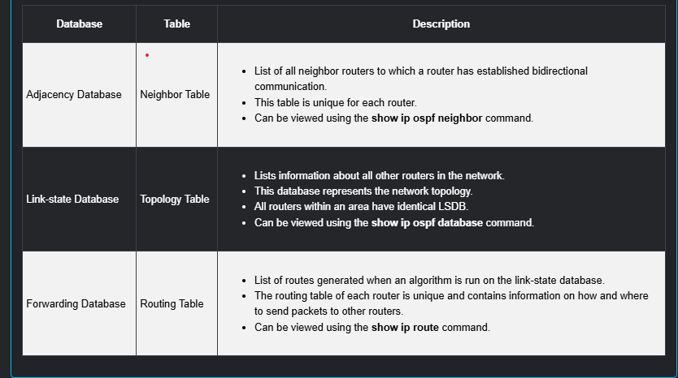

Algorithm - The router builds the topology table using results of calculations based on the Dijkstra shortest-path first (SPF) algorithm. The SPF algorithm is based on the cumulative cost to reach a destination.

The SPF algorithm creates an SPF tree by placing each router at the root of the tree and calculating the shortest path to each node. The SPF tree is then used to calculate the best routes. OSPF places the best routes into the forwarding database, which is used to make the routing table.

1.1.3 Link-State Operation

To maintain routing information, OSPF routers complete a generic link-state routing process to reach a state of convergence. In OSPF, cost is used to determine the best path to the destination. The following are the link-state routing steps that are completed by a router:

* Establish Neighbor Adjacencies - OSPF-enabled routers must recognize each other on the network before they can share information. An OSPF-enabled router sends Hello packets out all OSPF-enabled interfaces to determine if neighbors are present on those links. If a neighbor is present, the OSPF-enabled router attempts to establish a neighbor adjacency with that neighbor.
* Exchange Link-State Advertisements -After adjacencies are established, routers then exchange link-state advertisements (LSAs). LSAs contain the state and cost of each directly connected link. Routers flood their LSAs to adjacent neighbors. Adjacent neighbors receiving the LSA immediately flood the LSA to other directly connected neighbors, until all routers in the area have all LSAs.
* Build the Link State Database - After LSAs are received, OSPF-enabled routers build the topology table (LSDB) based on the received LSAs. This database eventually holds all the information about the topology of the area.
* Execute the SPF Algorithm - Routers then execute the SPF algorithm. The gears in the figure for this step are used to indicate the execution of the SPF algorithm. The SPF algorithm creates the SPF tree.
* Choose the Best Route.

1.1.4 Single-Area and Multiarea OSPF

To make OSPF more efficient and scalable, OSPF supports hierarchical routing using areas. An OSPF area is a group of routers that share the same link-state information in their LSDBs. OSPF can be implemented in one of two ways, as follows:

* Single-Area OSPF - All routers are in one area. Best practice is to use area 0.
* Multiarea OSPF - OSPF is implemented using multiple areas, in a hierarchical fashion. All areas must connect to the backbone area (area 0). Routers interconnecting the areas are referred to as Area Border Routers (ABRs).

1.1.5 Multiarea OSPF

With multiarea OSPF, one large routing domain can be divided into smaller areas, to support hierarchical routing. Routing still occurs between the areas (interarea routing), while many of the processor intensive routing operations, such as recalculating the database, are kept within an area.

For instance, any time a router receives new information about a topology change within the area (including the addition, deletion, or modification of a link) the router must rerun the SPF algorithm, create a new SPF tree, and update the routing table. The SPF algorithm is CPU-intensive and the time it takes for calculation depends on the size of the area.

Note: Routers in other areas receive updates regarding topology changes, but these routers only update the routing table, not rerun the SPF algorithm.

Too many routers in one area would make the LSDBs very large and increase the load on the CPU. Therefore, arranging routers into areas effectively partitions a potentially large database into smaller and more manageable databases.

The hierarchical-topology design options with multiarea OSPF can offer the following advantages.

* Smaller routing tables - Tables are smaller because there are fewer routing table entries. This is because network addresses can be summarized between areas. Route summarization is not enabled by default.
* Reduced link-state update overhead - Designing multiarea OSPF with smaller areas minimizes processing and memory requirements.
* Reduced frequency of SPF calculations - Multiarea OSPF localize the impact of a topology change within an area. For instance, it minimizes routing update impact because LSA flooding stops at the area boundary.

1.1.6 OSPFv3

OSPFv3 is the OSPFv2 equivalent for exchanging IPv6 prefixes. Recall that in IPv6, the network address is referred to as the prefix and the subnet mask is called the prefix-length.

Similar to its IPv4 counterpart, OSPFv3 exchanges routing information to populate the IPv6 routing table with remote prefixes.

Note: With the OSPFv3 Address Families feature, OSPFv3 includes support for both IPv4 and IPv6. OSPF Address Families is beyond the scope of this curriculum.

OSPFv2 runs over the IPv4 network layer, communicating with other OSPF IPv4 peers, and advertising only IPv4 routes.

OSPFv3 has the same functionality as OSPFv2, but uses IPv6 as the network layer transport, communicating with OSPFv3 peers and advertising IPv6 routes. OSPFv3 also uses the SPF algorithm as the computation engine to determine the best paths throughout the routing domain.

Review

Question 1

Which of the following OSPF components is associated with the neighbor table?

Adjacency database

Question 2

Which of the following OSPF components is responsible for computing the cost of each route?

Dijkstra's algorithm

Question 3

Which of the following OSPF components is associated with the topology table?

Link-State database

Question 4

Which of the following OSPF components is associated with the routing table?

Forwarding database

Question 5

What is the correct order in the steps for Link-State operation?

* Establish Neighbor Adjacencies
* Exchange Link-State Advertisements
* Build the Topology Table
* Execute the SPF Algorithm
* Choose the Best Route

1.2 OSPF Packets

1.2.2 Types of OSPF Packets

Link-state packets are the tools used by OSPF to help determine the fastest available route for a packet. OSPF uses the following link-state packets (LSPs) to establish and maintain neighbor adjacencies and exchange routing updates. Each packet serves a specific purpose in the OSPF routing process, as follows:

* Type 1: Hello packet - This is used to establish and maintain adjacency with other OSPF routers.
* Type 2: Database Description (DBD) packet - This contains an abbreviated list of the LSDB of the sending router and is used by receiving routers to check against the local LSDB. The LSDB must be identical on all link-state routers within an area to construct an accurate SPF tree.
* Type 3: Link-State Request (LSR) packet - Receiving routers can then request more information about any entry in the DBD by sending an LSR.
* Type 4: Link-State Update (LSU) packet - This is used to reply to LSRs and to announce new information. LSUs contain several different types of LSAs.
* Type 5: Link-State Acknowledgment (LSAck) packet - When an LSU is received, the router sends an LSAck to confirm receipt of the LSU. The LSAck data field is empty.

1. 1 Hello Discovers neighbors and builds adjacencies between them
2. 2 Database Description (DBD) Checks for database synchronization between routers
3. 3 Link-State Request (LSR) Requests specific link-state records from router to router
4. 4 Link-State Update (LSU) Sends specifically requested link-state records
5. 5 Link-State Acknowledgment (LSACk) Acknowledges the other packet types

1.2.3 Link-State Updates

Routers initially exchange Type 2 DBD packets, which is an abbreviated list of the LSDB of the sending router. It is used by receiving routers to check against the local LSDB.

A Type 3 LSR packet is used by the receiving routers to request more information about an entry in the DBD.

The Type 4 LSU packet is used to reply to an LSR packet.

A Type 5 packet is used to acknowledge the receipt of a Type 4 LSU.

LSUs are also used to forward OSPF routing updates, such as link changes. Specifically, an LSU packet can contain 11 different types of OSPFv2 LSAs.

Note: The difference between the LSU and LSA terms can sometimes be confusing because these terms are often used interchangeably. However, an LSU contains one or more LSAs.

1.2.4 Hello Packet

The OSPF Type 1 packet is the Hello packet. Hello packets are used to do the following:

* Discover OSPF neighbors and establish neighbor adjacencies.
* Advertise parameters on which two routers must agree to become neighbors.

Elect the Designated Router (DR) and Backup Designated Router (BDR) on multiaccess networks like Ethernet. Point-to-point links do not require DR or BDR.

Review

Question 1

Which of the following OSPF packets contains an abbreviated list of the LSDB of the sending router?

Type 2: DBD packet

Question 2

Which of the following OSPF packets is used by routers to announce new information?

Type 4: LSU packet

Question 3

Which of the following OSPF packets is used by routers to request more information?

Type 3: LSR packet

Question 4

Which of the following OSPF packets is responsible for establishing and maintaining adjacency with other OSPF routers?

Type 1: Hello packet

Question 5

Which of the following OSPF packets is used to confirm receipt of an LSA?

Type 5: LSAck packet

Question 6

Which of the following is used with the Hello Packet to uniquely identify the originating router?

Router ID

1.3 OSPF Operation

1.3.2 OSPF Operational States

Now that you know about the OSPF link-state packets, this topic explains how they work with OSPF-enabled routers. When an OSPF router is initially connected to a network, it attempts to:

* Create adjacencies with neighbors
* Exchange routing information
* Calculate the best routes
* Reach convergence

The table details the states OSPF progresses through while attempting to reach convergence:

|  |  |
| --- | --- |
| State | Description |
| Down state | * No Hello packets received = Down. * Router sends Hello packets. * Transition to Init state. |
| Init State | * Hello packets are received from the neighbor. * They contain the Router ID of the sending router. * Transition to Two-Way state |
| Two-way state | * In this state, communication between the two routers is bidirectional * On multiaccess links, the routers elect a DR and a BDR. * Transition to ExStartstate. |
| ExStart State | On point-to-point networks, the two routers decide which router will initiate the DBD packet exchange and decide upon the initial DBD packet sequence number. |
| Exchange State | * Routers exchange DBD packets * If additional router information is required then transition to Loading; otherwise, transition to the Full state. |
| Loading state | * LSRs and LSUs are used to gain additional route information. * Routes are processed using the SPF algorithm * Transition to the Full state. |
| Full state | The link-state database of the router is fully synchronized. |

1.3.3 Establish Neighbor Adjacencies

When OSPF is enabled on an interface, the router must determine if there is another OSPF neighbor on the link. To accomplish this, the router sends a Hello packet that contains its router ID out all OSPF-enabled interfaces. The Hello packet is sent to the reserved All OSPF Routers IPv4 multicast address 224.0.0.5. Only OSPFv2 routers will process these packets. The OSPF router ID is used by the OSPF process to uniquely identify each router in the OSPF area. A router ID is a 32-bit number formatted like an IPv4 address and assigned to uniquely identify a router among OSPF peers.

When a neighboring OSPF-enabled router receives a Hello packet with a router ID that is not within its neighbor list, the receiving router attempts to establish an adjacency with the initiating router.

Down state to Init state - When OSPFv2 is enabled, the enabled interface transitions from the Down state to the Init state. R1 starts sending Hello packets out all OSPF-enabled interfaces to discover OSPF neighbors to develop adjacencies with.

The Init state - R2 receives the Hello packet from R1 and adds the R1 router ID to its neighbor list. R2 then sends a Hello packet to R1. The packet contains the R2 Router ID and the R1 Router ID in its list of neighbors on the same interface.

Two-way state - R1 receives the Hello and adds the R2 Router ID to its list of OSPF neighbors. It also notices its own Router ID in the list of neighbors of the Hello packet. When a router receives a Hello packet with its Router ID listed in the list of neighbors, the router transitions from the Init state to the Two-Way state.

The action performed in Two-Way state depends on the type of interconnection between the adjacent routers, as follows:

* If the two adjacent neighbors are interconnected over a point-to-point link, then they immediately transition from the Two-Way state to the ExStart state.
* If the routers are interconnected over a common Ethernet network, then a designated router DR and a BDR must be elected.

Elect the DR and BDR - Because R1 and R2 are interconnected over an Ethernet network, a DR and BDR election takes place. This process only occurs on multiaccess networks such as Ethernet LANs.

Hello packets are continually exchanged to maintain router information.

1.3.4 Synchronizing OSPF Databases

After the Two-Way state, routers transition to database synchronization states. While the Hello packet was used to establish neighbor adjacencies, the other four types of OSPF packets are used during the process of exchanging and synchronizing LSDBs. This is a three step process, as follows:

* Decide first router - In the ExStart state, the two routers decide which router will send the DBD packets first. The router with the higher router ID will be the first router to send DBD packets during the Exchange state.
* Exchange DBDs - In the Exchange state, the two routers exchange one or more DBD packets. A DBD packet includes information about the LSA entry header that appears in the LSDB of the router. The entries can be about a link or about a network. Each LSA entry header includes information about the link-state type, the address of the advertising router, the cost of the link, and the sequence number. The router uses the sequence number to determine the newness of the received link-state information.
* Send an LSR - R1 compares the information received with the information it has in its own LSDB. If the DBD packet has a more current link-state entry, the router transitions to the Loading state.

After all LSRs have been satisfied for a given router, the adjacent routers are considered synchronized and in a full state. Updates (LSUs) are sent only to neighbors in the following conditions:

When a change is perceived (incremental updates)

Every 30 minutes

1.3.5 The Need for a DR

Why is a DR and BDR election necessary?

Multiaccess networks can create two challenges for OSPF regarding the flooding of LSAs, as follows:

* Creation of multiple adjacencies - Ethernet networks could potentially interconnect many OSPF routers over a common link. Creating adjacencies with every router is unnecessary and undesirable. It would lead to an excessive number of LSAs exchanged between routers on the same network.
* Extensive flooding of LSAs - Link-state routers flood their LSAs any time OSPF is initialized, or when there is a change in the topology. This flooding can become excessive.

To understand the problem with multiple adjacencies, we must study a formula:

For any number of routers (designated as n) on a multiaccess network, there are n (n - 1) / 2 adjacencies.

For example, the figure shows a simple topology of five routers, all of which are attached to the same multiaccess Ethernet network. Without some type of mechanism to reduce the number of adjacencies, collectively these routers would form 10 adjacencies:

5 (5 - 1) / 2 = 10

This may not seem like much, but as routers are added to the network, the number of adjacencies increases dramatically. For example, a multiaccess network with 20 routers would create 190 adjacencies.

1.3.6 LSA Flooding With a DR

A dramatic increase in the number of routers also dramatically increases the number of LSAs exchanged between the routers. This flooding of LSAs significantly impacts the operation of OSPF.

Flooding LSAs – A Router sends out an LSA. This event triggers every other router to also send out an LSA. If every router in a multiaccess network had to flood and acknowledge all received LSAs to all other routers on that same multiaccess network, the network traffic would become quite chaotic.

LSAs and DR - The solution to managing the number of adjacencies and the flooding of LSAs on a multiaccess network is the DR. On multiaccess networks, OSPF elects a DR to be the collection and distribution point for LSAs sent and received. A BDR is also elected in case the DR fails. All other routers become DROTHERs. A DROTHER is a router that is neither the DR nor the BDR.

Note: The DR is only used for the dissemination of LSAs. The router will still use the best next-hop router indicated in the routing table for the forwarding of all other packets.

Review

* In the Two-Way State on multiaccess networks, the routers elect a Designated Router (DR) and a Backup Designated Router (BDR).
* In the Exchange State, routers send each other DBD packets.
* In the Init State, Hello packets are received from neighbors, containing the sending Router ID.
* In the ExStart State on point-to-point networks, the routers decide which router initiates the exchange of DBD packets.
* In the Full State, routers have converged.
* In the Down State, no Hello packets are received.
* In the Loading State, routes are processed using the SPF algorithm.

1.4.2 Module Quiz - Single-Area OSPFv2 Concepts

Question 1

What is a function of OSPF hello packets?

To discover neighbors and build adjacencies between them

Topic 1.3.0 - The OSPF hello packet serves three primary functions: discover OSPF neighbors and establish adjacencies, advertise parameters that OSPF neighbors must agree on, and elect the DR and BDR.

Question 2

Which OSPF packet contains the different types of link-state advertisements?

LSU

Topic 1.2.0 - Link-state update (LSU) packets contain different types of link-state advertisements (LSAs). The LSUs are used to reply to link-state requests (LSRs) and to announce new information.

Question 3

Which three statements describe features of the OSPF topology table? (Choose three.)

It is a link-state database that represents the network topology.

When converged, all routers in an area have identical topology tables.

The table can be viewed via the show ip ospf database command.

Topic 1.1.0 - The topology table on an OSPF router is a link-state database (LSDB) that lists information about all other routers in the network, and represents the network topology. All routers within an area have identical link-state databases, and the table can be viewed using the show ip ospf database command. The EIGRP topology table contains feasible successor routes. This concept is not used by OSPF. The SPF algorithm uses the LSDB to produce the unique routing table for each router which contains the lowest cost route entries for known networks.

Question 4

What does an OSPF area contain?

Routers that have the same link-state information in their LSDBs

Topic 1.1.0 - An OSPF area contains one set of link-state information, although each router within the area will process that information individually to form its own SPF tree. OSPF process IDs are locally significant and are created by the administrator. Router IDs uniquely identify each router.

Question 5

A router is participating in an OSPFv2 domain. What will always happen if the dead interval expires before the router receives a hello packet from an adjacent DROTHER OSPF router?

OSPF will remove that neighbor from the router link-state database.

Topic 1.2.0 - On Cisco routers the default dead interval is 4 times the hello interval, and this timer has expired in this case. SPF does not determine the state of neighbor routers; it determines which routes become routing table entries. A DR/DBR election will not always automatically run; this depends on the type of network and on whether or not the router no longer up was a DR or BDR.

Question 6

What is the order of packet types used by an OSPF router to establish convergence?

Hello, DBD, LSR, LSU, LSAck

Topic 1.2.0 - An OSPF router progresses in this order to convergence, using the following packets:

* Hello packet, used for OSPF election and establishing neighbor adjacencies
* DBD packet, used to synchronize databases with neighbors
* LSR packet, used to request more information in synchronizing databases
* LSU packet, used to send link-state updates to neighbors
* LSAck packet, used to acknowledge receipt of an LSU

Question 7

What is a feature of the OSPF routing protocol?​

It scales well in both small and large networks.

Topic 1.1.0 - OSPF uses the SPF algorithm to choose the best path. Routing changes trigger routing updates (no 30-second updates). In IPv4, OSPF uses MD5 authentication between two neighboring OSPF routers. In IPv6, OSPFv3 does not include any authentication capabilities of its own. Instead it relies entirely on IPsec to secure communications between neighbors. Routers can be grouped into areas to support a hierarchical system.​

Question 8

What is used to create the OSPF neighbor table?

Adjacency database

Topic 1.1.0 - The adjacency database is used to create the OSPF neighbor table. The link-state database is used to create the topology table, and the forwarding database is used to create the routing table.

Question 9

What is identical on all OSPF routers within a single area?

Link-state database

Topic 1.1.0 - When the LSP flooding process completes, all OSPF routers will learn the same link-state information in the routing area. This information is used to build a complete link-state database, which will be the same on all OSPF routers within that specific area.

Question 10

What function is performed by the OSPF designated router?

Dissemination of LSAs

Topic 1.3.0 - OSPF designated routers are elected on multiaccess networks to disseminate LSAs to other OSPF routers. By having a single router disseminate LSAs, the exchanging of LSAs is more efficient.

Question 11

What are two reasons for creating an OSPF network with multiple areas? (Choose two.)

To reduce SPF calculations

To reduce use of memory and processor resources

Topic 1.1.0 - If a router is not running OSPF, it is not configurable with an OSPF area. OSPF areas have no direct relationship with the Internet. Routers that run OSPF can connect to the Internet, but multiple OSPF areas are not required for this purpose. OSPF areas help to decrease the demand for router memory and processing power by limiting OSPF protocol traffic, keeping link-state databases small, and requiring fewer SPF recalculations. Multiarea OSPF requires additional steps to configure and therefore does not simplify the configuration process.

Question 12

At which OSPF state are neighbor routers converged and able to exchange routing updates?

Full

Topic 1.3.0 - OSPF neighbors that reach the Full state are converged and can exchange routing information.

Question 13

The OSPF hello timer has been set to 15 seconds on a router in a point-to-point network. By default, what is the dead interval on this router?

60 seconds

Topic 1.2.0 - By default, the dead interval is calculated as 4 times the hello interval.

Question 14

What happens immediately after two OSPF routers have exchanged hello packets and have formed a neighbor adjacency?

They exchange abbreviated lists of their LSDBs.

Topic 1.2.0 - During the exchange of hello packets, OSPF routers negotiate the election process and set the OSPF parameters. DBD packets are exchanged after that step has been completed. DBD packets contain abbreviated lists of link-state information. After that information has been exchanged, OSPF routers exchange Type 3 LSR packets to request further information.

Question 15

Which statement is correct about multiarea OSPF?

Arranging routers into areas partitions a large autonomous system in order to lighten the load on routers.

Topic 1.1.0 - A company with one large autonomous system or AS can be divided into smaller areas. When this occurs and the OSPF routing protocol is implemented, the design is called multi-area OSPF. Multi-area OSPF decreases the frequency of the SPF calculation, thus lightening the load on the router. In a single area OSPF design, all the routers are located in area 0 or the backbone area.

2.0 Single-Area OSPFv2 Configuration!

2.1 OSPF Router ID

2.1.2 Router Configuration Mode for OSPF

OSPFv2 is enabled using the router ospf process-id global configuration mode command. The process-id value represents a number between 1 and 65,535 and is selected by the network administrator. The process-id value is locally significant, which means that it does not have to be the same value on the other OSPF routers to establish adjacencies with those neighbors. It is considered best practice to use the same process-id on all OSPF routers.

After entering the router ospf process-id command, the router enters router configuration mode

R1(config-router)# ?

* area OSPF area parameters
* auto-cost Calculate OSPF interface cost according to bandwidth
* default-information Control distribution of default information
* distance Define an administrative distance
* exit Exit from routing protocol configuration mode
* log-adjacency-changes Log changes in adjacency state
* neighbor Specify a neighbor router
* network Enable routing on an IP network
* no Negate a command or set its defaults
* passive-interface Suppress routing updates on an interface
* redistribute Redistribute information from another routing protocol
* router-id router-id for this OSPF process

2.1.3 Router IDs

An OSPF router ID is a 32-bit value, represented as an IPv4 address. The router ID is used to uniquely identify an OSPF router. All OSPF packets include the router ID of the originating router. Every router requires a router ID to participate in an OSPF domain. The router ID can be defined by an administrator or automatically assigned by the router. The router ID is used by an OSPF-enabled router to do the following:

* Participate in the synchronization of OSPF databases - During the Exchange State, the router with the highest router ID will send their database descriptor (DBD) packets first.
* Participate in the election of the designated router (DR) - In a multiaccess LAN environment, the router with the highest router ID is elected the DR. The routing device with the second highest router ID is elected the backup designated router (BDR).

2.1.4 Router ID Order of Precedence

But how does the router determine the router ID? Cisco routers derive the router ID based on one of three criteria, in the following preferential order:

* The router ID is explicitly configured using the OSPF router-id rid router configuration mode command. The rid value is any 32-bit value expressed as an IPv4 address. This is the recommended method to assign a router ID.
* If the router ID is not explicitly configured, the router chooses the highest IPv4 address of any of configured loopback interfaces. This is the next best alternative to assigning a router ID.
* If no loopback interfaces are configured, then the router chooses the highest active IPv4 address of any of its physical interfaces. This is the least recommended method because it makes it more difficult for administrators to distinguish between specific routers.

2.1.5 Configure a Loopback Interface as the Router ID

Instead of relying on physical interface, the router ID can be assigned to a loopback interface. Typically, the IPv4 address for this type of loopback interface should be configured using a 32-bit subnet mask (255.255.255.255). This effectively creates a host route. A 32-bit host route would not get advertised as a route to other OSPF routers.

R1(config-if)# interface Loopback 1

R1(config-if)# ip address 1.1.1.1 255.255.255.255

R1(config-if)# end

R1# show ip protocols | include Router ID

Router ID 1.1.1.1

2.1.6 Explicitly Configure a Router ID

Use the router-id rid router configuration mode command to manually assign a router ID. In the example, the router ID 1.1.1.1 is assigned to R1. Use the show ip protocols command to verify the router ID.

R1(config)# router ospf 10

R1(config-router)# router-id 1.1.1.1

R1(config-router)# end

R1# show ip protocols | include Router ID

Router ID 1.1.1.1

2.1.7 Modify a Router ID

After a router selects a router ID, an active OSPF router does not allow the router ID to be changed until the router is reloaded or the OSPF process is reset.

Use the clear ip ospf process command to reset the adjacencies.

2.2 Point-to-Point OSPF Networks

2.2.1 The network Command Syntax

One type of network classified by OSPF is a point-to-point network. You can specify the interfaces that belong to a point-to-point network by configuring the network command. You can also configure OSPF directly on the interface with the ip ospf command.

Both commands are used to determine which interfaces participate in the routing process for an OSPFv2 area. The basic syntax for the network command is as follows:

Router(config-router)# network network-address wildcard-mask area area-id.

The network-address wildcard-mask syntax is used to enable OSPF on interfaces. Any interfaces on a router that match the network address in the network command are enabled to send and receive OSPF packets.

The area area-id syntax refers to the OSPF area. When configuring single-area OSPFv2, the network command must be configured with the same area-id value on all routers. Although any area ID can be used, it is good practice to use an area ID of 0 with single-area OSPFv2. This convention makes it easier if the network is later altered to support multiarea OSPFv2.

2.2.2 The Wildcard Mask

The wildcard mask is typically the inverse of the subnet mask configured on that interface. In a subnet mask, binary 1 is equal to a match and binary 0 is not a match. In a wildcard mask, the reverse is true, as shown in here:

* Wildcard mask bit 0 - Matches the corresponding bit value in the address.
* Wildcard mask bit 1 - Ignores the corresponding bit value in the address.

The easiest method for calculating a wildcard mask is to subtract the network subnet mask from 255.255.255.255, as shown for /24 and /26 subnet masks in the figure.

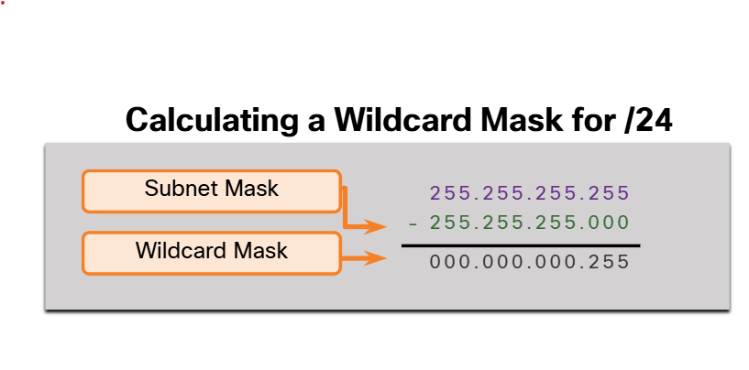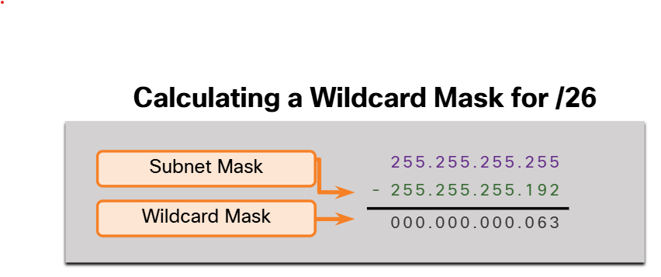

2.2.4 Configure OSPF Using the network Command

You are currently logged into R2:

* Enter OSPF router configuration mode using process ID 10
* Configure the R2 router ID of 2.2.2.2

R2(config)#router ospf 10

R2(config-router)#router-id 2.2.2.2

R2(config-router)#

Advertise the networks connected to R2 with the appropriate wildcard mask using area 0. Configure the networks in the following order:

* 10.10.2.0/24
* 10.1.1.4/30
* 10.1.1.8/30

R2(config-router)#network 10.10.2.0 0.0.0.255 area 0

R2(config-router)#network 10.1.1.4 0.0.0.3 area 0

R2(config-router)#network 10.1.1.8 0.0.0.3 area 0

R2(config-router)#

You are now configuring R3:

* Enter OSPF router configuration mode using process ID 10
* Configure the R3 router ID of 3.3.3.3.
* Use the network statement to enable OSPF based on the interface address and quad zero wildcard mask for area 0.
* Return to privileged EXEC mode when complete

R3(config)#router ospf 10

R3(config-router)#router-id 3.3.3.3

R3(config-router)#

Use the network statement to enable OSPF based on the interface address and quad zero wildcard mask for area 0. Configure the interfaces in the following order:

* 10.10.3.1
* 10.1.1.10
* 10.1.1.13

R3(config-router)#network 10.10.3.1 0.0.0.0 area 0

R3(config-router)#network 10.1.1.10 0.0.0.0 area 0

R3(config-router)#network 10.1.1.13 0.0.0.0 area 0

R3(config-router)#

R3#

You successfully advertised the OSPF networks on R2 and R3.

2.2.6 Configure OSPF Using the ip ospf Command

You can also configure OSPF directly on the interface instead of using the network command. To configure OSPF directly on the interface, use the ip ospf interface configuration mode command. The syntax is as follows:

Router(config-if)# ip ospf process-id area area-id

R1(config)# router ospf 10

R1(config-router)# no network 10.10.1.1 0.0.0.0 area 0

R1(config-router)# no network 10.1.1.5 0.0.0.0 area 0

R1(config-router)# no network 10.1.1.14 0.0.0.0 area 0

R1(config-router)# interface GigabitEthernet 0/0/0

R1(config-if)# ip ospf 10 area 0

R1(config-if)# interface GigabitEthernet 0/0/1

R1(config-if)# ip ospf 10 area 0

R1(config-if)# interface Loopback 0

R1(config-if)# ip ospf 10 area 0

R1(config-if)#

2.2.8 Passive Interface

By default, OSPF messages are forwarded out all OSPF-enabled interfaces. However, these messages really only need to be sent out interfaces that are connecting to other OSPF-enabled routers.

Sending out unneeded messages on a LAN affects the network in three ways, as follows:

* Inefficient Use of Bandwidth - Available bandwidth is consumed transporting unnecessary messages.
* Inefficient Use of Resources - All devices on the LAN must process and eventually discard the message.
* Increased Security Risk - Without additional OSPF security configurations, OSPF messages can be intercepted with packet sniffing software. Routing updates can be modified and sent back to the router, corrupting the routing table with false metrics that misdirect traffic.

2.2.9 Configure Passive Interfaces

Use the passive-interface router configuration mode command to prevent the transmission of routing messages through a router interface, but still allow that network to be advertised to other routers. The configuration example identifies the R1 Loopback 0/0/0 interface as passive.

R1(config)# router ospf 10

R1(config-router)# passive-interface loopback 0

R1(config-router)# end

R1# show ip protocols

You are currently logged into R2.

* Enter OSPF router configuration mode using process ID 10.
* Configure the Loopback interface as passive using the shortened interface name lo0.
* Return to privileged EXEC mode.
* Verify the OSPF settings with the show ip protocols command.

R2(config)#router ospf 10

R2(config-router)#passive-interface lo0

R2(config-router)#end

R2#show ip protocols

R2#

You are now logged into R3:

* Enter OSPF router configuration mode using process ID 10
* Use one command to configure all interfaces as passive
* Use the shortened interface names g0/0/0 and g0/0/1 to remove these interfaces from the passive list
* Return to privileged EXEC mode
* Verify the OSPF settings with the show ip protocols command.

R3(config)#router ospf 10

R3(config-router)#passive-interface default

R3(config-router)#end

R3#show ip protocols

R3#

You successfully configured passive interfaces for R2 and R3.

2.2.11 OSPF Point-to-Point Networks

By default, Cisco routers elect a DR and BDR on Ethernet interfaces, even if there is only one other device on the link.

The DR/ BDR election process is unnecessary as there can only be two routers on the point-to-point network.

To change to a point-to-point network, use the interface configuration command ip ospf network point-to-point on all interfaces where you want to disable the DR/BDR election process.

R1(config)# interface GigabitEthernet 0/0/0

R1(config-if)# ip ospf network point-to-point

2.2.12 Loopbacks and Point-to-Point Networks

We use loopbacks to provide additional interfaces for a variety of purposes. In this case, we are using loopbacks to simulate more networks than the equipment can support. By default, loopback interfaces are advertised as /32 host routes. For example, R1 would advertise the 10.10.1.0/24 network as 10.10.1.1/32 to R2 and R3.

R2# show ip route | include 10.10.1

* 10.10.1.1/32 [110/2] via 10.1.1.5, 00:03:05, GigabitEthernet0/0/0

To simulate a real LAN, the Loopback 0 interface is configured as a point-to-point network so that R1 will advertise the full 10.10.1.0/24 network to R2 and R3.

R1(config-if)# interface Loopback 0

R1(config-if)# ip ospf network point-to-point

Now R2 receives the more accurate, simulated LAN network address of 10.10.1.0/24.

R2# show ip route | include 10.10.1

* 10.10.1.0/24 [110/2] via 10.1.1.5, 00:00:30, GigabitEthernet0/0/0

2.3 Multiaccess OSPF Networks

2.3.1 OSPF Network Types

Another type of network that uses OSPF is the multiaccess OSPF network. Multiaccess OSPF networks are unique in that one router controls the distribution of LSAs. The router that is elected for this role should be determined by the network administrator through proper configuration.

OSPF may include additional processes depending on the type of network. Ethernet LANs are the most common example of broadcast multiaccess networks. In broadcast networks, all devices on the network see all broadcast and multicast frames.

2.3.2 OSPF Designated Router

Recall that, in multiaccess networks, OSPF elects a DR and BDR as a solution to manage the number of adjacencies and the flooding of link-state advertisements (LSAs). The DR is responsible for collecting and distributing LSAs sent and received. The DR uses the multicast IPv4 address 224.0.0.5 which is meant for all OSPF routers.

A BDR is also elected in case the DR fails. The BDR listens passively and maintains a relationship with all the routers. If the DR stops producing Hello packets, the BDR promotes itself and assumes the role of DR.

All other routers become a DROTHER (a router that is neither the DR nor the BDR). DROTHERs use the multiaccess address 224.0.0.6 (all designated routers) to send OSPF packets to the DR and BDR. Only the DR and BDR listen for 224.0.0.6.

2.3.4 Verify OSPF Router Roles

To verify the roles of the OSPFv2 router, use the show ip ospf interface command.

2.3.5 Verify DR/BDR Adjacencies

To verify the OSPFv2 adjacencies, use the show ip ospf neighbor command.

The state of neighbors in multiaccess networks can be as follows:

* FULL/DROTHER - This is a DR or BDR router that is fully adjacent with a non-DR or BDR router. These two neighbors can exchange Hello packets, updates, queries, replies, and acknowledgments.
* FULL/DR - The router is fully adjacent with the indicated DR neighbor. These two neighbors can exchange Hello packets, updates, queries, replies, and acknowledgments.
* FULL/BDR - The router is fully adjacent with the indicated BDR neighbor. These two neighbors can exchange Hello packets, updates, queries, replies, and acknowledgments.
* 2-WAY/DROTHER - The non-DR or BDR router has a neighbor relationship with another non-DR or BDR router. These two neighbors exchange Hello packets.

The normal state for an OSPF router is usually FULL. If a router is stuck in another state, it is an indication that there are problems in forming adjacencies. The only exception to this is the 2-WAY state, which is normal in a multiaccess broadcast network. For examples, DROTHERs will form a 2-WAY neighbor adjacency with any DROTHERs that join the network. When this happens, the neighbor state displays as 2-WAY/DROTHER.

2.3.6 Default DR/BDR Election Process

How do the DR and BDR get elected? The OSPF DR and BDR election decision is based on the following criteria, in sequential order:

* The routers in the network elect the router with the highest interface priority as the DR. The router with the second highest interface priority is elected as the BDR. The priority can be configured to be any number between 0 - 255. If the interface priority value is set to 0, that interface cannot be elected as DR nor BDR. The default priority of multiaccess broadcast interfaces is 1. Therefore, unless otherwise configured, all routers have an equal priority value and must rely on another tie breaking method during the DR/BDR election.
* If the interface priorities are equal, then the router with the highest router ID is elected the DR. The router with the second highest router ID is the BDR.

Recall that the router ID is determined in one of the following three ways:

* The router ID can be manually configured.
* If no router IDs are configured, the router ID is determined by the highest loopback IPv4 address.
* If no loopback interfaces are configured, the router ID is determined by the highest active IPv4 address.

2.3.7 DR Failure and Recovery

After the DR is elected, it remains the DR until one of the following events occurs:

The DR fails.

* The OSPF process on the DR fails or is stopped.
* The multiaccess interface on the DR fails or is shutdown.

If the DR fails, the BDR is automatically promoted to DR. This is the case even if another DROTHER with a higher priority or router ID is added to the network after the initial DR/BDR election. However, after a BDR is promoted to DR, a new BDR election occurs and the DROTHER with the highest priority or router ID is elected as the new BDR.

2.3.8 The ip ospf priority Command

If the interface priorities are equal on all routers, the router with the highest router ID is elected the DR. It is possible to configure the router ID to manipulate the DR/BDR election. However, this process only works if there is a stringent plan for setting the router ID on all routers. Configuring the router ID can help control this. However, in large networks this can be cumbersome.

Instead of relying on the router ID, it is better to control the election by setting interface priorities. This also allows a router to be the DR in one network and a DROTHER in another. To set the priority of an interface, use the command ip ospf priority value, where value is 0 to 255. A value of 0 does not become a DR or a BDR. A value of 1 to 255 on the interface makes it more likely that the router becomes the DR or the BDR.

2.3.9 Configure OSPF Priority

In the topology, the ip ospf priority command will be used to change the DR and BDR as follows:

* R1 should be the DR and will be configured with a priority of 255.
* R2 should be the BDR and will be left with the default priority of 1.
* R3 should never be a DR or BDR and will be configured with a priority of 0.

Change the R1 G0/0/0 interface priority from 1 to 255.

R1(config)# interface GigabitEthernet 0/0/0

R1(config-if)# ip ospf priority 255

R1(config-if)# end

R1#

Change the R3 G0/0/0 interface priority from 1 to 0.

R3(config)# interface GigabitEthernet 0/0/0

R3(config-if)# ip ospf priority 0

R3(config-if)# end

R3#

Example 2

Use the ip ospf priority command to change the DR and BDR as follows:

* R1 should be the BDR and will be configured with a priority of 10.
* R2 should never be a DR or BDR and will be configured with a priority of 0.
* R3 should be the DR and will be left with the default priority of 100.

On all routers, use g0/0/0 for the interface name.

You are logged into R1 in global configuration mode. Configure R1 with a priority of 10.

* R1(config)#interface g0/0/0
* R1(config-if)#ip ospf priority 10
* R1(config-if)#

You are now logged into R2 in global configuration mode. Configure R2 with a priority of 0.

* R2(config)#interface g0/0/0
* R2(config-if)#ip ospf priority 0
* R2(config-if)#

You are now logged into R3 in global configuration mode. Configure R3 with a priority of 100.

* R3(config)#interface g0/0/0
* R3(config-if)#ip ospf priority 100
* R3(config-if)#

You are still logged into R3 in interface configuration mode. Return to privileged EXEC mode. Because R3 is to be the DR, restart the OSPF process on it first.

* R3(config-if)#end
* R3#clear ip ospf process

You are now logged into R1 in privileged EXEC mode. Because R1 is the be the DR, restart the OSPF process on it next.

* R1#clear ip ospf process

You are now logged into R2 in privileged EXEC mode. R2 is to be DROTHER. Restart the OSPF process.

* R2#clear ip ospf process

You are now logged into R1. Use the show ip ospf interface g0/0/0 command to verify the R1 is the BDR.

* R1#show ip ospf interface g0/0/0

You are now logged into R2. Use the show ip ospf interface g0/0/0 command to verify the R2 is a DROTHER.

* R2#show ip ospf interface g0/0/0

You are now logged into R3. Use the show ip ospf interface g0/0/0 command to verify the R3 is the DR.

* R3#show ip ospf interface g0/0/0

You successfully changed the OSPF priority.

2.4 Modify Single-Area OSPFv2

2.4.1 Cisco OSPF Cost Metric

A routing protocol uses a metric to determine the best path of a packet across a network. A metric gives indication of the overhead that is required to send packets across a certain interface. OSPF uses cost as a metric. A lower cost indicates a better path than a higher cost.

The Cisco cost of an interface is inversely proportional to the bandwidth of the interface. Therefore, a higher bandwidth indicates a lower cost. The formula used to calculate the OSPF cost is:

Cost = reference bandwidth / interface bandwidth

The default reference bandwidth is 108 (100,000,000); therefore, the formula is:

Cost = 100,000,000 bps / interface bandwidth in bps

Manually set the OSPF cost value with the ip ospf cost command on necessary interfaces.

2.4.2 Adjust the Reference Bandwidth

The cost value must be an integer. If something less than an integer is calculated, OSPF rounds up to the nearest integer. Therefore, the OSPF cost assigned to a Gigabit Ethernet interface with the default reference bandwidth of 100,000,000 bps would equal 1, because the nearest integer for 0.1 is 0 instead of 1.

Cost = 100,000,000 bps / 1,000,000,000 = 1

For this reason, all interfaces faster than Fast Ethernet will have the same cost value of 1 as a Fast Ethernet interface. To assist OSPF in making the correct path determination, the reference bandwidth must be changed to a higher value to accommodate networks with links faster than 100 Mbps.

Changing the reference bandwidth does not actually affect the bandwidth capacity on the link; rather, it simply affects the calculation used to determine the metric. To adjust the reference bandwidth, use the auto-cost reference-bandwidth Mbps router configuration command.

Router(config-router)# auto-cost reference-bandwidth Mbps

This command must be configured on every router in the OSPF domain. Notice that the value is expressed in Mbps; therefore, to adjust the costs for Gigabit Ethernet, use the command auto-cost reference-bandwidth 1000. For 10 Gigabit Ethernet, use the command auto-cost reference-bandwidth 10000.

2.4.4 Manually Set OSPF Cost Value

Note: Changing the cost of link may have undesired consequences. Therefore, adjusting interface cost values should only be configured when the outcome is fully understood.

The administrator may want traffic to go through R2 and use R3 as a backup route in case the link between R1 and R2 goes down.

Another reason to change the cost value is because other vendors may calculate OSPF in a different manner. By manipulating the cost value, the administrator can make sure the route costs shared between OSPF multivendor routers are accurately reflected in routing tables.

To change the cost value reported by the local OSPF router to other OSPF routers, use the interface configuration command ip ospf cost value.

* R1(config)# interface g0/0/1
* R1(config-if)# ip ospf cost 30
* R1(config-if)# interface lo0
* R1(config-if)# ip ospf cost 10
* R1(config-if)# end
* R1#

2.4.7 Hello Packet Intervals

OSPFv2 Hello packets are transmitted to multicast address 224.0.0.5 (all OSPF routers) every 10 seconds. This is the default timer value on multiaccess and point-to-point networks.

The Dead interval is the period that the router waits to receive a Hello packet before declaring the neighbor down. If the Dead interval expires before the routers receive a Hello packet, OSPF removes that neighbor from its link-state database (LSDB). The router floods the LSDB with information about the down neighbor out all OSPF-enabled interfaces. Cisco uses a default of 4 times the Hello interval. This is 40 seconds on multiaccess and point-to-point networks.

Note: On non-broadcast multiaccess (NBMA) networks, the default Hello interval is 30 seconds and the default dead interval is 120 seconds.

2.4.8 Verify Hello and Dead Intervals

The OSPF Hello and Dead intervals are configurable on a per-interface basis. The OSPF intervals must match or a neighbor adjacency does not occur. To verify the currently configured OSPFv2 interface intervals, use the show ip ospf interface command.

Use the show ip ospf neighbor command to see the Dead Time counting down from 40 seconds.

2.4.9 Modify OSPFv2 Intervals

It may be desirable to change the OSPF timers so that routers detect network failures in less time. Doing this increases traffic, but sometimes the need for quick convergence is more important than the extra traffic it creates.

Note: The default Hello and Dead intervals are based on best practices and should only be altered in rare situations.

OSPFv2 Hello and Dead intervals can be modified manually using the following interface configuration mode commands:

* Router(config-if)# ip ospf hello-interval seconds
* Router(config-if)# ip ospf dead-interval seconds

Use the no ip ospf hello-interval and no ip ospf dead-interval commands to reset the intervals to their default.

2.5 Default Route Propagation

2.5.1 Propagate a Default Static Route in OSPFv2

Your network users will need to send packets out of your network to non-OSPF networks, such as the internet. This is where you will need to have a default static route that they can use.

The router connected to the internet is sometimes called the edge router or the gateway router. However, in OSPF terminology, the router located between an OSPF routing domain and a non-OSPF network is called the autonomous system boundary router (ASBR).

To propagate a default route, the edge router must be configured with the following:

* A default static route using the ip route 0.0.0.0 0.0.0.0 [next-hop-address | exit-intf] command.
* The default-information originate router configuration command. This instructs the router to be the source of the default route information and propagate the default static route in OSPF updates.

2.5.2 Verify the Propagated Default Route

You can verify the default route settings on R2 using the show ip route command.

Notice that the route source on R1 and R3 is O*E2, signifying that it was learned using OSPFv2. The asterisk identifies this as a good candidate for the default route. The E2 designation identifies that it is an external route. The meaning of E1 and E2 is beyond the scope of this module.

2.6 Verify Single-Area OSPFv2

2.6.1 Verify OSPF Neighbors

The following two commands are particularly useful for verifying routing:

* show ip interface brief - This verifies that the desired interfaces are active with correct IP addressing.
* show ip route- This verifies that the routing table contains all the expected routes.

Additional commands for determining that OSPF is operating as expected include the following:

* show ip ospf neighbor - to verify that the router has formed an adjacency with its neighboring routers. If the router ID of the neighboring router is not displayed, or if it does not show as being in a state of FULL, the two routers have not formed an OSPFv2 adjacency.
  + For each neighbor, this command displays the following:
  + Neighbor ID - This is the router ID of the neighboring router.
  + Pri - This is the OSPFv2 priority of the interface. This value is used in the DR and BDR election.
  + State - This is the OSPFv2 state of the interface. FULL state means that the router and its neighbor have identical OSPFv2 LSDBs. On multiaccess networks, such as Ethernet, two routers that are adjacent may have their states displayed as 2WAY. The dash indicates that no DR or BDR is required because of the network type.
  + Dead Time - This is the amount of time remaining that the router waits to receive an OSPFv2 Hello packet from the neighbor before declaring the neighbor down. This value is reset when the interface receives a Hello packet.
  + Address - This is the IPv4 address of the interface of the neighbor to which this router is directly connected.
  + Interface - This is the interface on which this router has formed adjacency with the neighbor.

Two routers may not form an OSPFv2 adjacency if the following occurs:

* The subnet masks do not match, causing the routers to be on separate networks.
* The OSPFv2 Hello or Dead Timers do not match.
* The OSPFv2 Network Types do not match.
* There is a missing or incorrect OSPFv2 network command.
* show ip protocols - a quick way to verify vital OSPF configuration information. This includes the OSPFv2 process ID, the router ID, interfaces explicitly configured to advertise OSPF routes, the neighbors the router is receiving updates from, and the default administrative distance, which is 110 for OSPF.
* show ip ospf - can also be used to examine the OSPFv2 process ID and router ID. This command displays the OSPFv2 area information and the last time the SPF algorithm was executed.
* show ip ospf interface - provides a detailed list for every OSPFv2-enabled interface. Specify an interface to display the settings of just that interface. This command shows the process ID, the local router ID, the type of network, OSPF cost, DR and BDR information on multiaccess links, and adjacent neighbors.

To get a quick summary of OSPFv2-enabled interfaces, use the show ip ospf interface brief command. This command is useful for seeing important information including the following:

* Interfaces are participating in OSPF
* Networks that are being advertised (IP Address/Mask)
* Cost of each link
* Network state
* Number of neighbors on each link

2.7.5 Module Quiz - Single-Area OSPFv2 Configuration

Question 1

Which criterion is preferred by the router to choose a router ID?

The router-id rid command

Topic 2.1.0 - The preferred order of criteria for Cisco routers to identify the router ID is: an explicitly configured router using the router-id rid command; the IP address of any configured loopback interface; and the IP address of any active interface on the router (it does not have to be an OSPF-enabled interface).

Question 2

Which wildcard mask would be used to advertise the 192.168.5.96/27 network as part of an OSPF configuration?

0.0.0.31

Topic 2.2.0 - The wildcard mask can be found by subtracting the subnet mask from 255.255.255.255.

Question 3

The following three networks are directly connected to an OSPF router; 192.168.0.0/24, 192.168.1.0/24, and 192.168.2.0/24. Which OSPF network command would advertise only the 192.168.1.0 network to neighbors?

Router(config-router)# network 192.168.1.0 0.0.0.255 area 0

Topic 2.2.0 - To advertise only the 192.168.1.0/24 network the wildcard mask used in the network command must match the first 24-bits exactly. To match bits exactly, a wildcard mask uses a binary zero. This means that the first 24-bits of the wildcard mask must be zero. The low order 8-bits can all be set to 1.

Question 4

Which three parameters should match in order for a pair of routers to form an adjacency when running OSPFv2? (Choose three.)

OSPFv2 type of network

Hello timer

Subnet mask

Topic 2.6.0 - For a couple of routers that are running OSPFv2 to form an adjacency, the following parameters must match: subnet mask, network type, hello and dead timers, a corresponding network command, and the authentication information.

Question 5

What are two features of the OSPF routing protocol? (Choose two.)

Calculates its metric using bandwidth

Uses Dijkstra's algorithm to build the SPF tree

Topic 2.4.0 - Characteristics of OSPF include the following:

* Interior gateway protocol
* Link-state
* Classless
* Cost metric based on bandwidth
* Dijkstra algorithm
* Builds topological map
* Event-driven updates
* Hierarchical design
* Requires additional memory, CPU processing, and more initial bandwidth than other protocols

Question 6

A router with two LAN interfaces, two WAN interfaces, and one configured loopback interface is operating with OSPF as its routing protocol. What does the router OSPF process use to assign the router ID?

The loopback interface IP address

Topic 2.1.0 - OSPF requires a unique router ID on each router. The router ID can be configured manually with the # router-id command. If this command is not issued, then the OSPF process will use the highest IPv4 address on an active interface as the router ID, with preference give to loopback interfaces.

Question 7

Which verification command would identify the specific interfaces on a router that were configured with the passive-interface command?

show ip protocols

Topic 2.2.0 - The show ip protocols command will identify interfaces that are configured as passive.

Question 8

Which command, if applied on an OSPF router, would give a Gigabit Ethernet interface a lower cost than a Fast Ethernet interface?

(config-router)# auto-cost reference-bandwidth 1000

Topic 2.4.0 - OSPF uses the formula; Cost = 100,000,000 / bandwidth. Because OSPF will only use integers as cost, any bandwidth of 100 Mb/s or greater will all equal a cost of 1. To change this behavior, a new reference bandwidth can be configured. The new reference bandwidth will need to be larger than 100,000,000. In this case it needs to be 1,000,000,000. This is accomplished with the command auto-cost reference-bandwidth 1000, which means multiply the unit Mb/s by 1000. The result is 1,000,000,000.

Question 9

A network administrator has just changed the router ID on a router that is working in an OSPFv2 environment. What should the administrator do to reset the adjacencies and use the new router ID?

Issue the clear ip ospf process privileged mode command.

Topic 2.1.0 - If the router ID has changed on a working router, the OSPFv2 process must be cleared for the new router ID to take effect.

Question 10

Which command can be used to view the OSPF hello and dead time intervals?

show ip ospf interface

Topic 2.4.0 - The OSPF hello and dead timers can be configured per interface. Hence, the correct command used to view the timers is the show ip ospf interface command. Adding the interface name and number to the command displays output for a specific interface.

Question 11

What does the SPF algorithm consider to be the best path to a network?

The path that includes the fastest cumulative bandwidth links.

Topic 2.4.0 - Link-state protocols use accumulated cost to reach destination networks. The shortest path is not always the path with the least number of hops but instead the overall fastest pathway.

Question 12

What is one use of the router ID in OSPF routing?

The router ID can be used to break a tie in the election process.

Topic 2.3.0 - The OSPF router ID uniquely identifies each router within an OSPF area, and allows each router to participate in the election process in that area. On multiaccess networks, if there is no router priority value configured on the routers, and if there is a tie in the election, the router with the highest router ID is elected DR. The router priority value is a value chosen by the administrator and manually configured on the router. The administrator can manually configure the router ID, or the router can automatically assign itself its highest IPv4 loopback or physical address as the router ID. That interface has to be up but does not have to be participating in the OSPF process.

Question 13

What is the first criterion used by OPSF routers to elect a DR?

Highest priority

Topic 2.3.0 - When electing a DR, the router with the highest OSPF priority becomes the DR. If all routers have the same priority, then the router with the highest router ID is elected.

Question 14

Which command could be used on a router to ensure that an OSPF adjacency is formed with another router?

show ip ospf neighbor

Topic 2.6.0 - The show ip ospf neighbor command is a common command to use when an expected route does not appear in the routing table from the OSPFv2 routing protocol.

Question 15

A router in an OSPF enterprise network has a default static route that has been configured via the interface that connects to the ISP. Which command would the network administrator apply on this router so that other routers in the OSPF network will use this default route?

default-information originate

Topic 2.5.0 - When an OSPF router is configured with a static route first and the default-information originate router configuration command is applied, the router declares itself to be the source of the default route information and propagates the default static route in OSPF updates to all other routers in the OSPF area.

Checkpoint Exam: OSPF Concepts and Configuration Exam

Question 1

To establish a neighbor adjacency two OSPF routers will exchange hello packets. Which two values in the hello packets must match on both routers? (Choose two.)

dead interval

hello interval

The hello and dead interval timers contained in a hello packet must be the same on neighboring routers in order to form an adjacency.

Question 2

What is a benefit of multiarea OSPF routing?

Topology changes in one area do not cause SPF recalculations in other areas.

With multiarea OSPF, only routers within an area share the same link-state database. Changes to the network topology in one area do not impact other areas, which reduces the number of SPF algorithm calculations and the of link-state databases.

Question 3

Which type of OSPFv2 packet contains an abbreviated list of the LSDB of a sending router and is used by receiving routers to check against the local LSDB?

database description

The database description (DBD) packet contains an abbreviated list of the LSDB sent by a neighboring router and is used by receiving routers to check against the local LSDB.

Question 4

In an OSPF network when are DR and BDR elections required?

when the routers are interconnected over a common Ethernet network

When the routers are interconnected over a common Ethernet network, then a designated router (DR) and a backup DR (BDR) must be elected.

Question 5

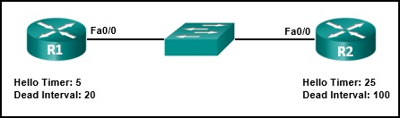

Refer to the exhibit. A network administrator has configured the OSPF timers to the values that are shown in the graphic. What is the result of having those manually configured timers?

The R1 dead timer expires between hello packets from R2.

The dead timer (20 seconds) on R1 expires before the next hello packet from R2 (25 seconds).

Question 6

What is the default router priority value for all Cisco OSPF routers?

1

The router priority value is used in a DR/BDR election. The default priority for all OSPF routers is 1 but it can be manually altered to any value 0 to 255.

Question 7

A network engineer has manually configured the hello interval to 15 seconds on an interface of a router that is running OSPFv2. By default, how will the dead interval on the interface be affected?

The dead interval will now be 60 seconds.

Cisco IOS automatically modifies the dead interval to four times the hello interval.

Question 8

Match each OSPF packet type to how it is used by a router.

* link-state request packet - query another router for additional information
* link-state update packet - advertise new information
* hello packet - establish and maintain adjacencies
* database description packet - compare local topology to that sent by another router

Question 9

Which OSPF data structure is identical on all OSPF routers that share the same area?

link-state database

Regardless of which OSPF area a router resides in, the adjacency database, routing table, and forwarding database are unique for each router. The link-state database lists information about all other routers within an area and is identical across all OSPF routers participating in that area.

Question 10

Match the OSPF state with the order in which it occurs.

* first state - Down state
* second state - Init state
* third state - Two-way state
* fourth state - Exstart state
* fifth state - Exchange state
* sixth state - Loading state
* seventh state - Full state

Question 11

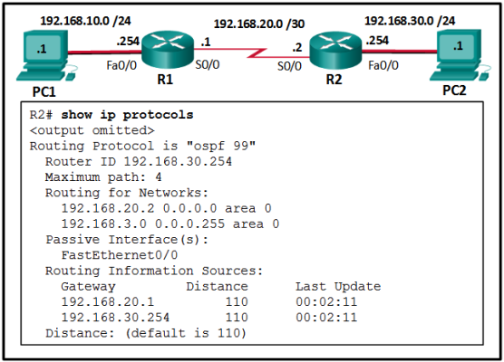

Refer to the exhibit. A network administrator has configured OSPFv2 on the two Cisco routers but PC1 is unable to connect to PC2. What is the most likely problem?

Interface s0/0 has not been activated for OSPFv2 on router R2.

If a LAN network is not advertised using OSPFv2, a remote network will not be reachable. The output displays a successful neighbor adjacency between router R1 and R2 on the interface S0/0 of both routers.

Question 12

What is the recommended Cisco best practice for configuring an OSPF-enabled router so that each router can be easily identified when troubleshooting routing issues?

Configure a value using the router-id command.

A Cisco router is assigned a router ID to uniquely identify it. It can be automatically assigned and take the value of the highest configured IP address on any interface, the value of a specifically-configured loopback address, or the value assigned (which is in the exact form of an IP address) using the router-id command. Cisco recommends using the router-id command.

Question 13

By default, what is the OSPF cost for any link with a bandwidth of 100 Mb/s or greater?

1

OSPF uses the formula: Cost = 100,000,000 / bandwidth. Because OSPF will only use integers as cost, any bandwidth of 100 Mb/s or greater will all equal a cost of 1.

Question 14

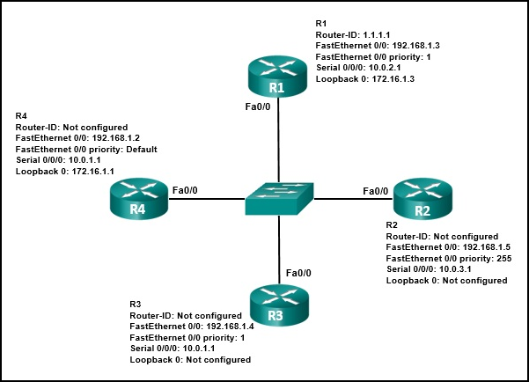

Refer to the exhibit. Which three statements describe the results of the OSPF election process of the topology that is shown in the exhibit? (Choose three.)

The R4 router ID is 172.16.1.1.

R3 will be elected BDR.

R2 will be elected DR.

R2 will be elected DR because it has the highest priority of 255, all of the others have a priority of 1. R3 will be elected BDR because it has the numerically highest router-ID of 192.168.1.4. The R4 router-ID is 172.16.1.1 because it is the IPv4 address attached to the loopback 0 interface.

Question 15

What command would be used to determine if a routing protocol-initiated relationship had been made with an adjacent router?

show ip ospf neighbor

While the show ip interface brief and ping commands can be used to determine if Layer 1, 2, and 3 connectivity exists, neither command can be used to determine if a particular OSPF or EIGRP-initiated relationship has been made. The show ip protocols command is useful in determining the routing parameters such as timers, router ID, and metric information associated with a specific routing protocol. The show ip ospf neighbor command shows if two adjacent routers have exchanged OSPF messages in order to form a neighbor relationship.

Question 16

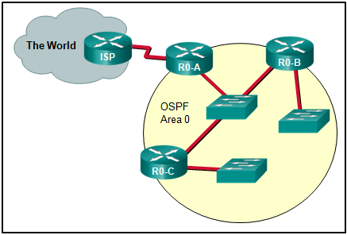

Refer to the exhibit. On which router or routers would a default route be statically configured in a corporate environment that uses single area OSPF as the routing protocol?

R0-A

The default route is applied to the router that connects to the Internet, or R0-A. R0-A then distributes that default route using the OSPF routing protocol.

Question 17

An OSPF router has three directly connected networks; 172.16.0.0/16, 172.16.1.0/16, and 172.16.2.0/16. Which OSPF network command would advertise only the 172.16.1.0 network to neighbors?

router(config-router)# network 172.16.1.0 0.0.0.0 area 0

To advertise only the 172.16.1.0/16 network the wildcard mask used in the network command must match the first 16-bits exactly. To match bits exactly, a wildcard mask uses a binary zero. This means that the first 16-bits of the wildcard mask must be zero. The low order 16-bits can all be set to 1.

Question 18

Which command is used to verify that OSPF is enabled and also provides a list of the networks that are being advertised by the network?​

show ip protocols

The command show ip ospf interface verifies the active OSPF interfaces. The command show ip interface brief is used to check that the interfaces are operational. The command show ip route ospf displays the entries that are learned via OSPF in the routing table. The command show ip protocols checks that OSPF is enabled and lists the networks that are advertised.

Question 19

What are the two purposes of an OSPF router ID? (Choose two.)

to facilitate router participation in the election of the designated router

to uniquely identify the router within the OSPF domain

OSPF router ID does not contribute to SPF algorithm calculations, nor does it facilitate the transition of the OSPF neighbor state to Full. Although the router ID is contained within OSPF messages when router adjacencies are being established, it has no bearing on the actual convergence process.

Question 20

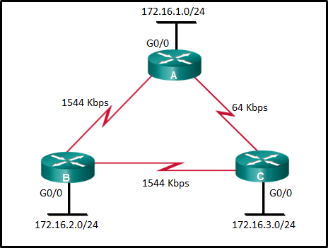

Refer to the exhibit. What is the OSPF cost to reach the router A LAN 172.16.1.0/24 from B?

65

The formula used to calculate the OSPF cost is as follows:

Cost = reference bandwidth / interface bandwidth

The default reference bandwidth is 10^8 (100,000,000); therefore, the formula is

Cost = 100,000,000 bps / interface bandwidth in bps

Thus the cost to reach the A LAN 172.16.1.0/24 from B is as follows:

Serial link (1544 Kbps) from B to A cost => 100,000,000 / 1,544,000 = 64

Gigabit Ethernet link on A cost => 100,000,000 / 1,000,000,000 = 1

Total cost to reach 172.16.1.0/24 = 64 + 1 = 65

Question 20

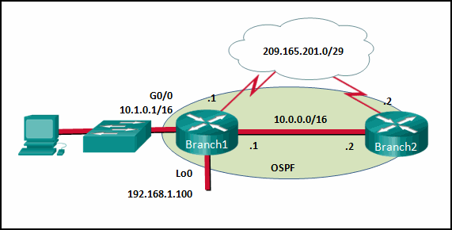

Refer to the exhibit. If no router ID was manually configured, what would router Branch1 use as its OSPF router ID?

192.168.1.100

In OSPFv2, a Cisco router uses a three-tier method to derive its router ID. The first choice is the manually configured router ID with the router-id command. If the router ID is not manually configured, the router will choose the highest IPv4 address of the configured loopback interfaces. Finally if no loopback interfaces are configured, the router chooses the highest active IPv4 address of its physical interfaces.

Question 21

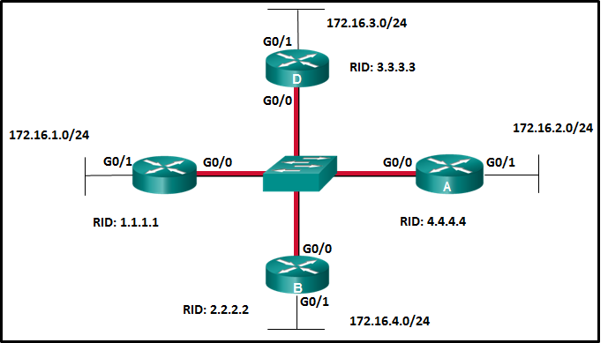

Refer to the exhibit. Suppose that routers B, C, and D have a default priority, and router A has a priority 0. Which conclusion can be drawn from the DR/BDR election process?​

If the DR fails, the new DR will be router B.

If the priority of router C is changed to 255, then it will become the DR.

If the priority is set to 0, the router is not capable of becoming the DR, so router A cannot be the DR. OSPF DR and BDR elections are not preemptive. If a new router with a higher priority or higher router ID is added to the network after the DR and BDR election, the newly added router does not take over the DR or the BDR role.​

Question 22

A network technician issues the following commands when configuring a router:

R1(config)# router ospf 11

R1(config-router)# network 10.10.10.0 0.0.0.255 area 0

Question 24

What does the number 11 represent?

the OSPF process ID on R1

There is no autonomous system number to configure on OSPF. The area number is located at the end of the network statement. The cost of a link can be modified in the interface configuration mode. The process ID is local to the router.

Question 23

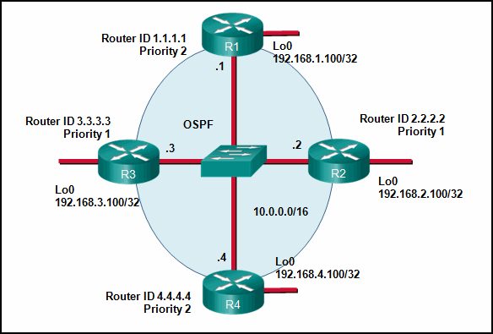

Refer to the exhibit. If the switch reboots and all routers have to re-establish OSPF adjacencies, which routers will become the new DR and BDR?

Router R4 will become the DR and router R1 will become the BDR.

OSPF elections of a DR are based on the following in order of precedence:

highest pritority from 1 -255 (0 = never a DR)

highest router ID

highest IP address of a loopback or active interface in the absence of a manually configured router ID. Loopback IP addresses take higher precedence than other interfaces.

In this case routers R4 and R1 have the highest router priority. Between the two, R3 has the higher router ID. Therefore, R4 will become the DR and R1 will become the BDR.

Question 24

What will an OSPF router prefer to use first as a router ID?

any IP address that is configured using the router-id command

The first preference for an OSPF router ID is an explicitly configured 32-bit address. This address is not included in the routing table and is not defined by the network command. If a router ID that is configured through the router-id command is not available, OSPF routers next use the highest IP address available on a loopback interface, as loopbacks used as router IDs are also not routable addresses. Lacking either of these alternatives, an OSPF router will use the highest IP address from its active physical interfaces.

Question 25

Match the description to the term.

* All the routers are in the backbone area.- Single-area OSPF
* This is where the details of the neighboring routers can be found. - Adjacency database
* This is where you can find the topology table. - Link-state database
* This is the algorithm used by OSPF- Shortest Path First

Question 26

After modifying the router ID on an OSPF router, what is the preferred method to make the new router ID effective?

HQ# clear ip ospf process

To modify a router-id on an OSPF-enabled router, it is necessary to reset the OSPF routing process by entering either the clear ip ospf process command or the reload command.

Question 27

In an OSPFv2 configuration, what is the effect of entering the command network 192.168.1.1 0.0.0.0 area 0?

It tells the router which interface to turn on for the OSPF routing process.

Entering the command network 192.168.1.1 0.0.0.0 area 0 will turn on only the interface with that IP address for OSPF routing. It does not change the router ID. Instead, OSPF will use the network that is configured on that interface.

Question 30

What is the reason for a network engineer to alter the default reference bandwidth parameter when configuring OSPF?

to more accurately reflect the cost of links greater than 100 Mb/s

By default, Fast Ethernet, Gigabit, and 10 Gigabit Ethernet interfaces all have a cost of 1. Altering the default reference bandwidth alters the cost calculation, allowing each speed to be more accurately reflected in the cost.

Question 31

What is the format of the router ID on an OSPF-enabled router?

a 32-bit number formatted like an IPv4 address

A router ID is a 32-bit number formatted like an IPv4 address and assigned in order to uniquely identify a router among OSPF peers.

Question 32

Which step in the link-state routing process is described by a router flooding link-state and cost information about each directly connected link?

exchanging link-state advertisements

Question 33

An administrator is configuring single-area OSPF on a router. One of the networks that must be advertised is 198.19.0.0 255.255.252.0. What wildcard mask would the administrator use in the OSPF network statement?

255.255.255.255 – 255.255.252.0 =

*0.0.3.255*

3.0 Network Security Concepts!